|  |
| --- |
|  |
| |  | | --- | | New World Development Company Limited | | Lung Tin Tsuen Phase 3 | | Building Energy Simulation Report | |  | | Issue3 | 30 November 2018 | |

|  |  |  |
| --- | --- | --- |
| This report takes into account the particular  instructions and requirements of our client.  It is not intended for and should not be relied  upon by any third party and no responsibility  is undertaken to any third party.  Job number -- |  | ArupLogo2010_k_OvaWord1000mm_CompoundTransparent_100kGreyscale.wmf |
|  |
| **Ove Arup & Partners Hong Kong Ltd**  Level 5 Festival Walk  80 Tat Chee Avenue  Kowloon Tong  Kowloon  Hong Kong  www.arup.com |

|  |  |  |  |  |  |  |  |  |  |  |  |
| --- | --- | --- | --- | --- | --- | --- | --- | --- | --- | --- | --- |
| Document Verification | | | | | | ArupLogo2010_k_OvaWord1000mm_CompoundTransparent_100kGreyscale.wmf | | | | | |
|  | | | | | |  | | | | | |
|  | | |  | | | | |  | | | |
| Job title | | | Lung Tin Tsuen Phase 3 | | | | | Job number | | | |
| -- | | | |
|  | | |  | | | | |  | | | |
| Document title | | | Building Energy Simulation Report | | | | | File reference | | | |
|  | | | |
|  | | |  | | | | | | | | |
| Document ref | | |  | | | | | | | | |
|  | |  |  |  | | | | | | | |
| Revision | | Date | Filename | 180608\_EU1\_Energy simulation report\_v1.docx | | | | | | | |
|  | |  |  |  | | | | | | | | |
| Issue | | 8 Jun 2018 | Description | Issue | | | | | | | |
|  | Prepared by | | Checked by | | Approved by | | | |
| Name | Kelvin Chow | | Ricky Li | | Tony Lam | | | |
| Signature |  | |  | |  | | | |
|  | |  |  |  | | | | | | | | |
| Issue2 | | 18 Sep 2018 | Filename | EU1\_Energy simulation report\_v2.docx | | | | | | | |
| Description | Issue2 | | | | | | | |
|  | Prepared by | | Checked by | | Approved by | | | |
| Name | Katsuya Obara | | Ricky Li | | Tony Lam | | | |
| Signature |  | |  | |  | | | |
|  | |  |  |  | | | | | | | | |
| Issue3 | | 30 Nov 2018 | Filename | EU1\_Energy simulation report\_v3.docx | | | | | | | |
| Description | Issue3 | | | | | | | |
|  | Prepared by | | Checked by | | Approved by | | | |
| Name | Katsuya Obara | | Ricky Li | | Tony Lam | | | |
| Signature |  | |  | |  | | | |
|  | |  |  |  | | | | | | | | |
|  | |  | Filename |  | | | | | | | |
| Description |  | | | | | | | |
|  | Prepared by | | Checked by | | Approved by | | | |
| Name |  | |  | |  | | | |
| Signature |  | |  | |  | | | |
|  | | | | | | | | | | |
| Press **Control+Shift+D** to insert or remove DV sheet | | | | Issue Document Verification with Document | | | |  | ✓ |  |
|  | | | | | | | | | | |

Contents

Page

[Executive Summary 1](#_Toc531335565)

[1 Introduction 5](#_Toc531335566)

[2 Methodology 7](#_Toc531335567)

[2.1 Energy/CO2 Emission Performance Assessment Framework 7](#_Toc531335568)

[2.2 Simulation Approach 9](#_Toc531335569)

[2.3 Simulation Software 9](#_Toc531335570)

[2.4 Simulation Procedures 11](#_Toc531335571)

[2.5 Reference Codes or Guidelines 11](#_Toc531335572)

[2.6 Exceptional Calculation Method 12](#_Toc531335573)

[3 Project Information 13](#_Toc531335574)

[3.1 General Description 13](#_Toc531335575)

[3.2 General Weather Information 14](#_Toc531335576)

[3.3 Space Information 15](#_Toc531335577)

[4 Energy Conservation Measures 16](#_Toc531335578)

[4.1 Reducing building façade glazing area 16](#_Toc531335579)

[4.2 Common area efficient lighting strategies 16](#_Toc531335580)

[4.3 Energy saving AC units in residential flats 16](#_Toc531335581)

[4.4 Efficient lift power consumption 16](#_Toc531335582)

[5 Modelling Parameters 17](#_Toc531335583)

[5.1 Input Parameters Summary Table 18](#_Toc531335584)

[5.2 Exceptional Calculation Method 25](#_Toc531335585)

[6 Results and discussion 27](#_Toc531335586)

[6.1 EU 1 Reduction of CO2 Emissions 27](#_Toc531335587)

[6.2 Simulation Results 27](#_Toc531335588)

[6.3 EU 2 Peak Electricity Demand Reduction 33](#_Toc531335589)

[7 Conclusion 36](#_Toc531335590)

References

Tables

Figures

Drawings

Pictures

Photographs

Attachments

Appendices

Executive Summary

As part of the consultancy agreement, an energy simulation is required to fulfil the related EU credits. This report details the energy performance analysis of Lung Tin Tsuen Phase 3, in accordance with BEAM Plus for New Buildings version 1.2 for the fulfilment of credits EU1 and EU2.

The project is located at Shap Pat Heung Road, Lot No. 4056 in D.D. 120, Yuen Long. It is a residential development consists of 1-tower with 20 floors of residential flats. Carpark is located on B1/F and the Clubhouse is located on G/F. The project is located in the residential area in Yuen Long, south of Lung Tin Tsuen. Its neighbouring buildings include Park Signature, The Grove and The Green Atrium.

In order to achieve the targeted energy savings, the following energy efficient and green feature were implemented:

Energy Efficiency Features:

* Building envelope – reduce building façade glazing area
* Efficient lighting strategies in common areas
* More energy efficient AC units compared with BEC 2015
* Energy efficient power consumption for lift compared with BEC 2015

The whole building energy performance analysis was carried out using the validated software EnergyPlus V.8.7.0 and the analysis methodology is referenced to ASHRAE 90.1 Appendix G, BEAM Plus Manual and BEC 2015.

**EU 1 Reduction of CO2 Emissions**

The energy simulation results show that total amount of CO2 emission in Baseline Case for tower and parking space is **1,275,741 kgCO2/yr, 51,496 kgCO2/yr** respectively while the Proposed Case has **1,097,950 kgCO2/yr, 35,316 kgCO2/yr**. This results a **13.9%, 31.4%** of total CO2 emission reduction respectively. Thus, the project can achieve 12 points for tower part and 15 points for parking space under EU 1 credit.

Table Summary of assessment on CO2 emission reduction for residential tower

|  |  |  |  |
| --- | --- | --- | --- |
| **Residential Tower** | | | |
| **Categories** | **Baseline Case** | **Proposed Case** | **% Saving** |
|  | **(kgCO2)/year** | **(kgCO2)/year** |  |
| Cooling | 377,905 | 240,502 | 36% |
| Lighting | 229,368 | 217,859 | 5% |
| Equipment | 103,152 | 103,152 | 0% |
| Lift | 193,034 | 164,079 | 15% |
| Electric Cooking | 73,414 | 73,414 | 0% |
| Washing Machine | 52,781 | 52,781 | 0% |
| Refrigeration | 191,932 | 191,932 | 0% |
| Mechanical Ventilation | 1,447 | 1,447 | 0% |
| Hot water | 34,285 | 34,285 | 0% |
| Plumbing & Drainage | 18,425 | 18,425 | 0% |
| **Total CO2 Emission (kgCO2)** | **1,275,741** | **1,097,950** | **13.9%** |
| **No. of credit attained** | **12** | | |

Table Summary of assessment on CO2 emission reduction for car park

|  |  |  |  |
| --- | --- | --- | --- |
| **Car Park** | | | |
| **Categories** | **Baseline Case** | **Proposed Case** | **% Saving** |
|  | **(kgCO2)/year** | **(kgCO2)/year** |  |
| Lighting | 26,538 | 10,297 | 61.2% |
| Mechanical Ventilation | 24,957 | 25,019 | -0.2% |
| **Total CO2 Emission (kgCO2)** | **51,496** | **35,316** | **31.4%** |
| **No. of credit attained** | **15** | | |

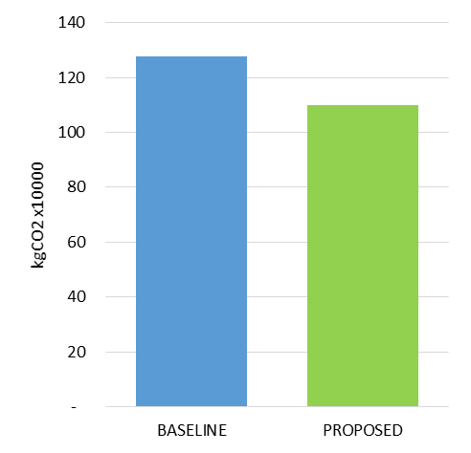

**13.9% Reduction**

Figure Overall CO2 emission reduction for residential tower

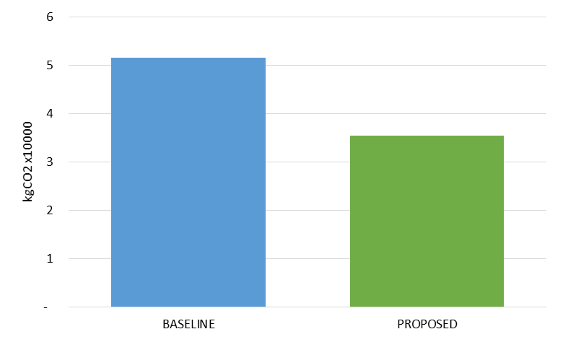

**31.4% Reduction**

Figure Overall CO2 emission reduction for car park

**EU 2 Peak Electricity Demand Reduction**

Through the energy simulation, the Baseline Case shows that the peak electricity demand that occur in June for residential tower due to the peak cooling period. Compared the electricity demand in June between Baseline and Proposed Case, there is around **12.2%** reduction for residential tower and **31.4%** reduction for car park in peak demand. Thus, according to the requirement in EU 2 credit, the project can achieve 3 points for residential tower and 3 points for car park respectively.

Table Summary of monthly peak electricity demand for residential tower

|  |  |  |  |
| --- | --- | --- | --- |
| **Residential Tower** | | | |
| **Month** | **Baseline Case** | **Proposed Case** | **% Reduction** |
|  | **kW** | **kW** |  |
| January | 542.6 | 531.5 | 2.0% |
| February | 542.6 | 531.5 | 2.0% |
| March | 542.6 | 531.5 | 2.0% |
| April | 682.1 | 617.4 | 9.5% |
| May | 707.9 | 635.7 | 10.2% |
| June | 741.3 | 650.6 | 12.2% |
| July | 740.4 | 649.8 | 12.2% |
| August | 729.1 | 645.0 | 11.5% |
| September | 730.2 | 645.6 | 11.6% |
| October | 702.6 | 628.4 | 10.5% |
| November | 542.6 | 531.5 | 2.0% |
| December | 542.6 | 531.5 | 2.0% |
| **Peak Demand Reduction** | | | **12.2%** |
| **No. of credit attained** | **3** | | |

Table Summary of monthly peak electricity demand for car park

|  |  |  |  |
| --- | --- | --- | --- |
| **Car Park** | | | |
| **Month** | **Baseline Case** | **Proposed Case** | **% Reduction** |
|  | **kW** | **kW** |  |
| January | 8.4 | 5.8 | 31.4% |
| February | 8.4 | 5.8 | 31.4% |
| March | 8.4 | 5.8 | 31.4% |
| April | 8.4 | 5.8 | 31.4% |
| May | 8.4 | 5.8 | 31.4% |
| June | 8.4 | 5.8 | 31.4% |
| July | 8.4 | 5.8 | 31.4% |
| August | 8.4 | 5.8 | 31.4% |
| September | 8.4 | 5.8 | 31.4% |
| October | 8.4 | 5.8 | 31.4% |
| November | 8.4 | 5.8 | 31.4% |
| December | 8.4 | 5.8 | 31.4% |
| **Peak Demand Reduction** | | | **31.4%** |
| **No. of credit attained** | **3** | | |

1. Introduction

Ove Arup & Partners Hong Kong Ltd. (Arup) was commissioned by New World Development Company Limited to be the BEAM Plus Consultant for the Lung Tin Tsuen (LTT) Phase 3 to accomplish a BEAM Plus certification under Version 1.2 for New Buildings.

“Building Environmental Assessment Method” (BEAM Plus) is a voluntary, third-party verified building rating system for commercial buildings developed by the Hong Kong Green Building Council (HKGBC) to provide a local consensus in what constitutes a “green” building and to provide market incentives to build green. This residential development is targeted to be certified as BEAM Plus Gold rating in Hong Kong. By promoting sustainability, both developer and owners of this development can acquire favourable reputation for the enhancement of corporate social responsibility.

Energy performance is one of the most important components of green building. Energy conservation would bring the economic and environmental benefits to the project as well as the society. In Hong Kong, energy mainly is produced by fossil fuels which create air and water pollution. CO2, a greenhouse gas that is a major contributor to climate change, has also increased from year to year because of the excess energy use.

In this connection, New World Development Company Limited decided to develop an energy efficient residential building complex. From the architects and MEP engineers to contractors, the project team diligently pursued an integrated design process in order to implement the required green strategies to achieve significant energy savings.

This report aims to illustrate the Energy Conservation Measures (ECMs) applied in LTT Phase 3 as well as the methodology for quantifying ECMs in terms of energy consumption and CO2 saving percentages.

1. Methodology
   1. Energy/CO2 Emission Performance Assessment Framework

The building energy performance assessment is based on the energy budget approach, which aligns BEAM Plus with international practices. This flexible approach can cater for a wide range of building types and trade-offs are allowed within a certain design features including the envelope design, the energy/CO2 emission performance of major equipment and the installed lighting intensities. The ‘energy budget’ for an assessed/proposed building is the predicted annual energy use for a ‘baseline’ building. The key features of the BEAM Plus methodologies are summarized as below.

* The baseline building model has the same shape and dimensions, and comprises the same mix of areas and types of premises the assessed building (except for window-to-wall ratio adjustment to meet the relevant regulatory requirement).
* The baseline building model incorporates a range of standard characteristics such that the model represents a building that has energy performance that barely meets the relevant regulatory requirements or meets only basic design quality.
* The predicted annual energy use/ CO2 emission of the assessed/proposed building will be based on its specific design characteristics.
* The number of credits awarded is determined by the percentage reduction in the predicted annual energy use/CO2 emission of the assessed building relative to the baseline building.

The below figure illustrates the energy performance assessment framework.

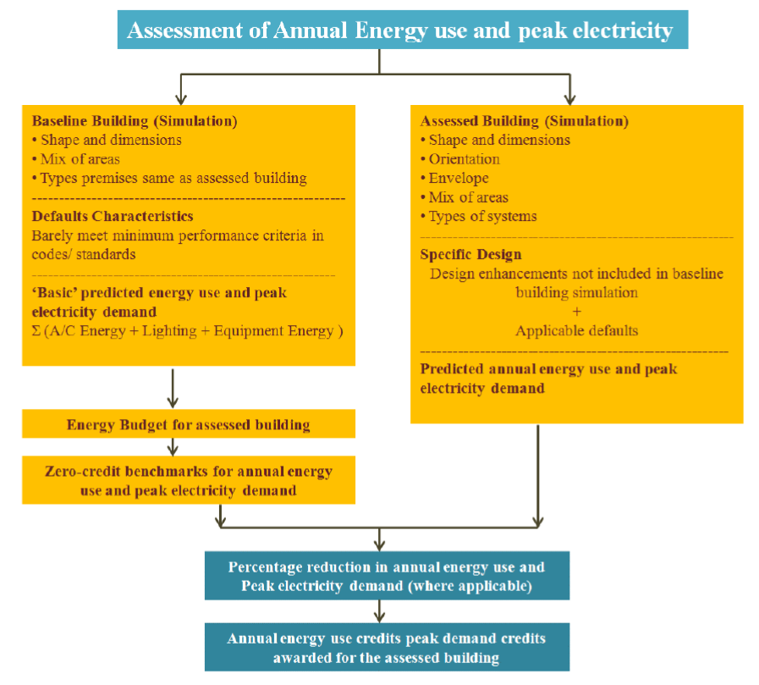

Figure Energy performance assessment framework – New building

* 1. Simulation Approach

Energy models are set up for the two scenarios. Design parameters as listed below are incorporated into the models.

* Outdoor weather/climate data of Hong Kong – the outdoor climatic condition including temperature, humidity, solar radiation, etc.
* Building data – configuration of building envelope and the internal load pattern (e.g. power density of lighting & equipment, occupancy schedule, etc.)
* HVAC System data - the specification of the HVAC system (e.g. air handling unit, fan coil, etc.) adopted for the building
* Plant data – the settings of the central plant (e.g. type of chillers / cooling towers)

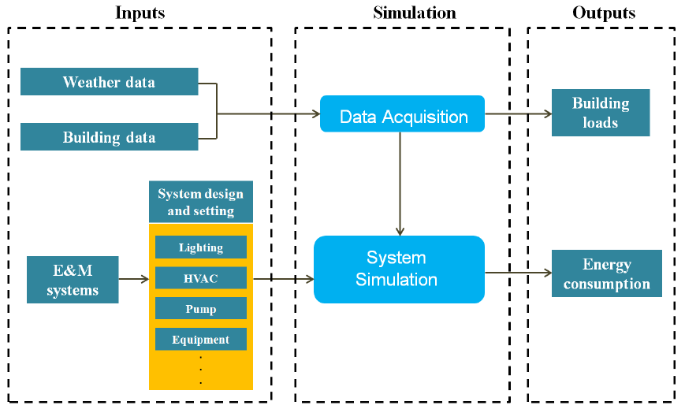

Figure Simulation input and output

* 1. Simulation Software

The energy simulation was conducted using software – EnergyPlus 8.8.0, which is an energy analysis and thermal load simulation program that simulates the building in a computer generated virtual environment. The EnergyPlus software conducts comprehensive performance analyses for different levels and phases of building design. The software satisfies all the requirements for BEAM Plus Submission which refers to ASHRAE 90.1-2007 Appendix G and BEC 2015, and has been tested in accordance with ASHRAE Standard 140; it meets or exceeds all requirements of this test.

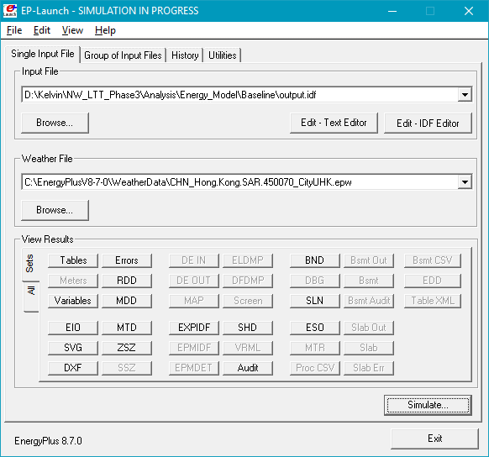

Figure EnergyPlus energy simulation interface

EnergyPlus is a suite of integrated building energy and environmental performance modelling software tools. The key simulation engine capabilities underlying the EnergyPlus can be summarized as follows:

* Dynamic Thermal Simulation
* HVAC Equipment and Controls System Simulation
* Sub-hourly, user-definable time steps for the interaction between the thermal zones and the environment
* Heat balance based solution
* Thermal comfort models
* Advanced fenestration calculations
* Daylighting controls calculation
* Loop based configurable HVAC systems (conventional and radiant)
* Atmospheric pollution calculations

EnergyPlus is one of the accredited simulation programmes for BEAM Plus submission. Capabilities of EnergyPlus fulfil the requirements described in Building Energy Code 2007 Edition and also ASHRAE Standard 140.

The energy simulations for the designed building and reference building in this project were based on the assumptions and modelling methodology described in BEAM Plus NB version 1.2, BEC 2015, and ASHRAE 90.1 – Appendix G.

* 1. Simulation Procedures

The project would implement the optimization of energy performance according to the requirements of BEAM Plus Energy Use pre-requisite 1, Credit 1 and Credit 2. A percentage of CO2 emission improvement by the Energy Conservation Measures (ECMs) in the Design CO2 Emission compared to the Total CO2 Emission of Reference/Baseline Building per EMSD Code of Practice for Energy Efficiency 2015 with the recent amendment regarding lighting power density and BEAM Plus Version 1.2 Standard is demonstrated by a whole building simulation.

In this study, energy and so the CO2 emission analysis was carried out based on the following procedures:

1. Set up Assessed Building Model according to architectural design, building services design intent and requirement; some building characteristics can be reference to the BEAM Plus NB v1.2, EMSD Code of Practice for Energy Efficiency 2015, etc.
2. For unspecified items not listed in BEAM Plus Manual, assume the system settings for Baseline case are the same as Design case.
3. Incorporate a range of standard characteristics such that the model represents a building whole energy performance barely meets the relevant regulatory requirements or meets only ‘basic’ design quality.
4. Carry out energy simulation and determine the Energy Budget of the assessed model and baseline model.
5. Estimate the energy saving compared with the baseline model.
6. Exceptional Calculation will be conducted for those energy saving strategies that cannot be accurately modelled/simulated by the program.
   1. Reference Codes or Guidelines

According to BEAM Plus v1.2 standard, some reference codes or guidelines should be followed accordingly, including

* BEAM Plus Standard Version 1.2 New Buildings
* Code of Practice for Energy Efficiency of Building Services Installation, 2015 Edition
* Technical Guidelines on Code of Practice for Energy Efficiency of Building Services Installation. 2015 Edition

The input parameters of baseline model and assessed proposed model would be according to those reference codes or guidelines, and reasonable assumptions.

* 1. Exceptional Calculation Method

Since some of the energy saving strategies cannot be properly modelled by the simulation engine, detail calculation is provided for further supporting on the energy calculation.

Section G2.5 of ASHRAE 90.1 2007 stipulates that when no simulation program can adequately model a design, material, or device, the rating authority (HKGBC) may approve an exceptional calculation method to demonstrate above-standard performance. Applications for approval of an exceptional method must include documentation of the calculations performed and theoretical and/ or empirical information supporting the accuracy of the method. The BEAM Plus reviewer evaluates whether the exceptional calculations can substantiate the energy savings and whether the energy saving are entered appropriately in the BEAM Plus submittal template.

In this project, Exceptional Calculation approaches are adopted for the energy estimation of all kitchen appliances such as electric cooking, washing machine and refrigeration.

1. Project Information

This section describes the project information for the proposed development building simulations.

* 1. General Description

The project is located at Shap Pat Heung Road, Lot No. 4056 in D.D. 120, Yuen Long. It is a residential development consists of 1-tower with 20 floors of residential flats. Carpark is located on B1/F and the Clubhouse is located on G/F. The project is located in the residential area in Yuen Long, south of Lung Tin Tsuen. Its neighbouring buildings include Park Signature, The Grove and The Green Atrium.

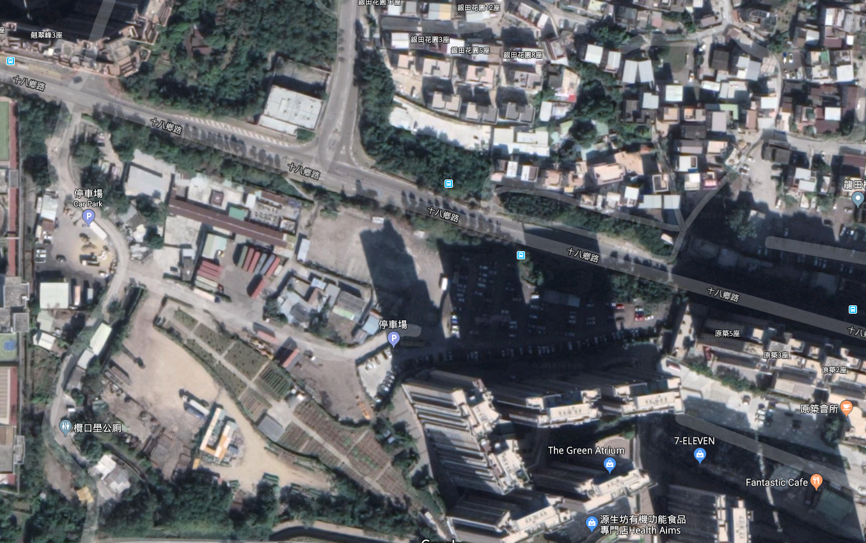

**The Development Site**

**N**

**Shap Pat Heung Road**

**Yuen Long Tai Yuk Road**

**Park Signature**

**La Grove**

Figure Site Location of the Development

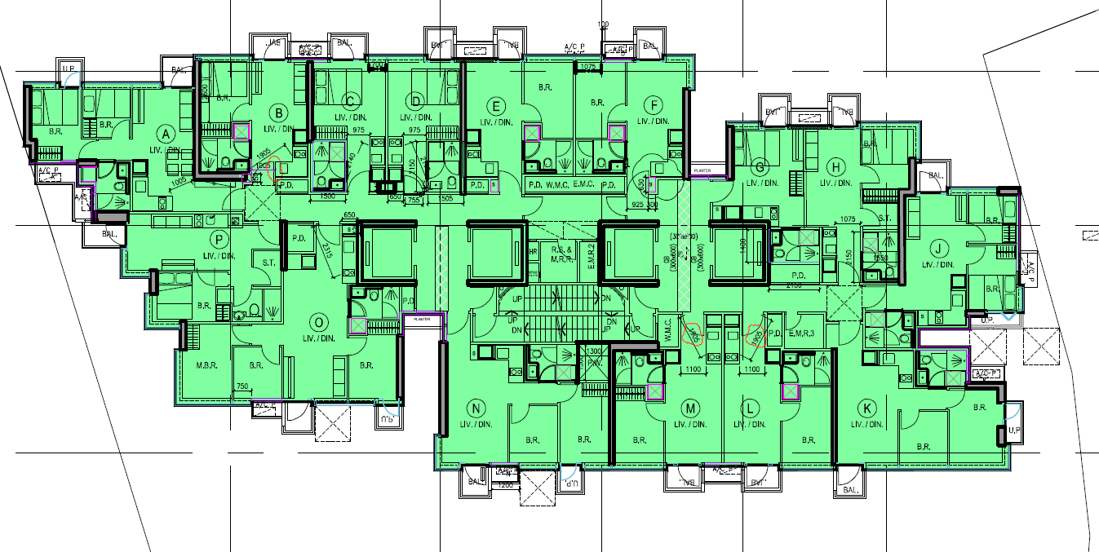

Figure Residential tower typical layout plan

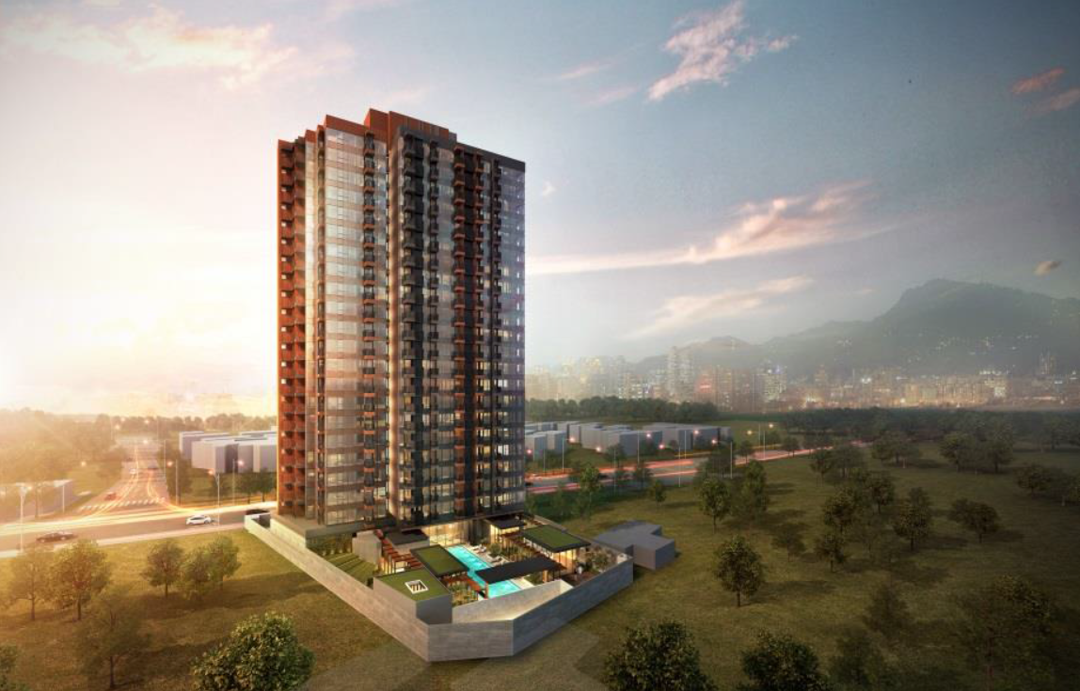

Figure Rendering for the development

* 1. General Weather Information

|  |  |
| --- | --- |
| Location | Hong Kong |
| Source of Design Weather | ASHRAE design weather database v4.0 |
| ASHRAE weather location | Hong Kong Observatory, China |
| Time Zone | GMT +8.0 Hours |
| Latitude | 22.3o N, 114.17o E |
| Principal Energy Source | Electricity |
| Weather File | CHN\_Hong.Kong.SAR\_CityUHK.BIN  Test Reference Year file for Hong Kong originally in IWEC format spreadsheet jointly developed by Dr TT Chow and ALS Chan of the City University of Hong Kong supported by a CERG grant from the Research Grants Council of the Hong Kong Special Administrative Region of China. Solar radiation measured from observatory station at 22.32 N, 114.17 E, 65 m above mean sea level. |
| Monthly Percentile for (Heating, Cooling) Loads Design Weather (%) | 99.60, 0.4 |

* 1. Space Information

This section describes the development space configuration.

|  |  |
| --- | --- |
| General Building Information | |
| Building Type | Residential Development |
| Site Area (m2) | 2,251 |
| Total GFA (m2) | 11,248.4 |
| Number of Storeys | 21 domestic floors (1-21/F)  1 floor carpark (B/F)  1 floor clubhouse and lobby (G/F) |
| Construction Floor Area (m2) | 14,531.3 |

1. Energy Conservation Measures

Numbers of Energy Conservation Measures (ECMs) are applied in this project to achieve the energy saving target. This section introduces those measures which have significant contribution to energy saving.

* 1. Reducing building façade glazing area

Solar Radiation is one of the key cooling loads for buildings in Hong Kong. Increasing the window area allow more solar radiation transmit into the interior area, which in turns increase the cooling loads and air-conditioning energy.

The Window-toWall Ratio (WWR) of the project building is lower than that in Baseline Case. Reducing the façade glazing area help to reduce the façade heat gain. Therefore, the overall cooling energy can be saved.

* 1. Common area efficient lighting strategies

By optimizing the lighting layout and overall lux level, more efficient lighting fixtures can be used in the building common area. Lighting engineer will choose the lighting fixtures with lower lighting power density in order to achieve energy saving.

* 1. Energy saving AC units in residential flats

The average COP of the single-split type and multi-split type AC units are higher than Baseline Case. Compared with the COP of 2.6 as stated in the BEC 2015 for Baseline Case, more energy efficient AC units has been adopted in the residential flats. Thus, a large amount of cooling energy can be saved.

* 1. Efficient lift power consumption

Compared with the lift power consumption with BEC2015 as the Baseline Case, Proposed Case use a more energy efficient motor which come up a significant energy saving.

1. Modelling Parameters

The modelling parameters for the Baseline Model were made reference to the settings for the Reference Building model for energy study as stipulated in BEAM Plus v1.2 Manual. Regarding the Proposed model, detailed design specification is listed in the summary table of section 5.1.

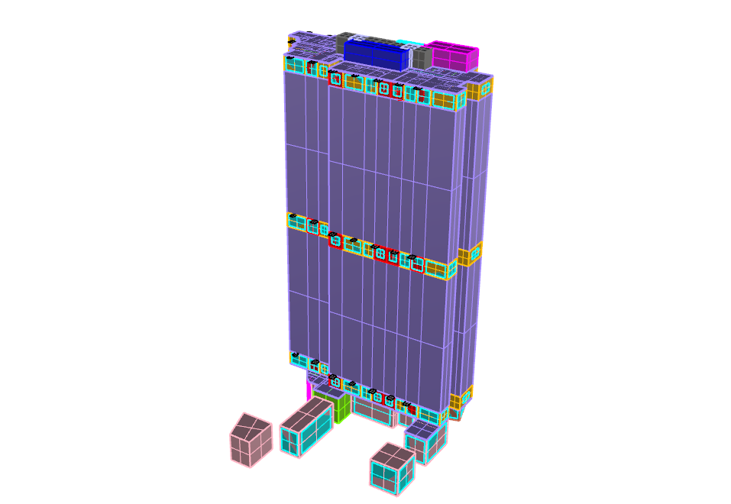

**N**

Figure 3D model for energy modelling

The table below presents the comparison of proposed design versus baseline design energy model inputs. These include the descriptions for:

* Exterior wall, roof, floor, and slab assemblies including framing type, assembly U-values, and roof reflectivity.
* Fenestration types, assembly U-values (including the impact of the frame on the assembly), SHGCs, and visual light transmittances, overall window-to-gross wall ratio and fixed shading devices.
* Interior lighting power densities, process lighting power.
* Equipment, escalators and other process loads.
* HVAC system information including types and efficiencies.
* Schedule information
  1. Input Parameters Summary Table

The Model parameters and information of baseline case and design case can be summarized and listed in the table as below.

**Building Envelope**

|  |  |  |
| --- | --- | --- |
| Model Input Parameter | Proposed Design Input | Reference Building/ Baseline Design Input\* |
| Roof  Design Case  *(Please refer to Building Material Specifications for details)*  Baseline Case  *(With reference to BEAM Plus default characteristics for other types building)* | Layer 1 – Concrete Tiles fixed with cement slurry  Thickness (m): 0.035  Thermal conductivity (W/mK): 1.1  Solar absorptivity: 0.7  Layer 2 – Cement / Sand Bedding  Thickness (m): 0.04  Thermal conductivity (W/mK): 0.72  Layer 3 – Extruded Polystyrene Form  Thickness (m): 0.04  Thermal conductivity (W/mK): 0.034  Layer 4 – Cement / Sand Screed  Thickness (m): 0.02  Thermal conductivity (W/mK): 0.72  **U-value for roof: 0.66 W/m2.K** | Layer 1 – Concrete Tiles  Thickness (m): 0.005  Thermal conductivity (W/mK): 1.1  Density (kg/m3): 2100  Specific heat (J/kgK): 920  Solar absorptivity: 0.65  Layer 2 – Asphalt  Thickness (m): 0.02  Thermal conductivity (W/mK): 1.15  Density (kg/m3): 2350  Specific heat (J/kgK): 1200  Layer 3 – Cement/Sand Screed  Thickness (m): 0.05  Thermal conductivity (W/mK): 0.72  Density (kg/m3): 1860  Specific heat (J/kgK): 840  Layer 4 – Expanded Polystyrene  Thickness (m): 0.05  Thermal conductivity (W/mK): 0.034  Density (kg/m3): 25  Specific heat (J/kgK): 1380  Layer 5 – Heavy Concrete  Thickness (m): 0.15  Thermal conductivity (W/mK): 2.16  Density (kg/m3): 2400  Specific heat (J/kgK): 840  Layer 6 – Gypsum Plaster  Thickness (m): 0.01  Thermal conductivity (W/mK): 0.38  Density (kg/m3): 1120  Specific heat (J/kgK): 840  Solar absorptivity: 0.65  **U-value for roof: 0.55 W/m2.K** |
| External Wall Construction  Design Case  *(Please refer to Building Material Specifications for details)*  Baseline Case  *(With reference to BEAM Plus default characteristics for other types building)* | (Type 1)  Layer 1 – Mosaic Tiles  Thickness (m): 0.005  Thermal conductivity (W/mK): 1.5  Solar absorptivity: 0.84  Layer 2 – Cement Screeding  Thickness (m): 0.03  Thermal conductivity (W/mK): 0.72  Layer 3 – Concrete Wall  Thickness (m): 0.15  Thermal conductivity (W/mK): 2.16  Layer 4 – Gypsum Plaster  Thickness (m): 0.015  Thermal conductivity (W/mK): 0.38  **U-value for Type 1 wall: 3.15W/m2.K**  (Type 2)  Layer 1 – Glass  Thickness (m): 0.01  Thermal conductivity (W/mK): 1.05  Solar absorptivity: 0.84  Layer 2 – Cement Screeding  Thickness (m): 0.01  Thermal conductivity (W/mK): 0.72  Layer 3 – Concrete Wall  Thickness (m): 0.1  Thermal conductivity (W/mK): 2.16  Layer 3 – Gypsum Plaster  Thickness (m): 0.015  Thermal conductivity (W/mK): 0.38  **U-value for Type 2 wall: 2.31W/m2.K**  (Type 3)  Layer 1 – Glass  Thickness (m): 0.01  Thermal conductivity (W/mK): 1.05  Solar absorptivity: 0.84  Layer 2 – Cement Screeding  Thickness (m): 0.01  Thermal conductivity (W/mK): 0.72  Layer 3 – Concrete Wall  Thickness (m): 0.4  Thermal conductivity (W/mK): 2.16  Layer 3 – Gypsum Plaster  Thickness (m): 0.015  Thermal conductivity (W/mK): 0.38  **U-value for Type 3 wall: 1.75W/m2.K**  (Type 4)  Layer 1 – Mosaic Tiles  Thickness (m): 0.005  Thermal conductivity (W/mK): 1.5  Solar absorptivity: 0.84  Layer 2 – Cement Screeding  Thickness (m): 0.03  Thermal conductivity (W/mK): 0.72  Layer 3 – Concrete Wall  Thickness (m): 0.25  Thermal conductivity (W/mK): 2.16  Layer 4 – Gypsum Plaster  Thickness (m): 0.015  Thermal conductivity (W/mK): 0.38  **U-value for Type 4 wall: 2.75W/m2.K**  (Type 5)  Layer 1 – Glass  Thickness (m): 0.01  Thermal conductivity (W/mK): 1.05  Solar absorptivity: 0.84  Layer 2 – Cement Screeding  Thickness (m): 0.185  Thermal conductivity (W/mK): 160  **U-value for Type 5 wall: 5.74W/m2.K**  **Area weighted Average U-value for wall: 2.99W/m2.K** | Layer 1 – Mosaic Tiles  Thickness (m): 0.005  Thermal conductivity (W/mK): 1.5  Density (kg/m3): 2500  Specific heat (J/kgK): 840  Solar absorptivity: 0.58  Layer 2 – Cement/Sand Plastering  Thickness (m): 0.01  Thermal conductivity (W/mK): 0.72  Density (kg/m3): 1860  Specific heat (J/kgK): 840  Layer 3 – Heavy Concrete  Thickness (m): 0.1  Thermal conductivity (W/mK): 2.13  Density (kg/m3): 2400  Specific heat (J/kgK): 840  Layer 4 – Gypsum Plastering  Thickness (m): 0.01  Thermal conductivity (W/mK): 0.38  Density (kg/m3): 1120  Specific heat (J/kgK): 840  Solar absorptivity: 0.65  **U-value for wall: 3.84W/m2.K** |
| Window-to-Gross Wall Ratio (WWR) | **WWR (Overall): 0.37**  *(Input as designed, with reference to Building Elevation Drawings)* | **WWR: 0.4**  *(With reference to BEAM Plus default characteristics for residential building)* |
| Fenestration Properties  Design Case  *(Please refer to Building Material Specifications for details)*  Baseline Case  *(With reference to BEAM Plus default characteristics for other types building)* | Tinted Glass  Thickness (m): 0.006 (crystal grey) + 0.012 (air gap) + 0.012 (low iron)  **U-value: 1.63W/m2.K**  **Shading Coefficient: 0.35** | Tinted Glass  Thickness (m): 0.006  Thermal conductivity (W/mK): 1.05  Density (kg/m3): 2500  Specific heat (J/kgK): 840  Solar absorptivity: 0.65  **U-value: 5.32W/m2.K**  **Shading Coefficient: 0.65** |
| Shading Devices (Overhang / Fin) | Yes | Yes |
| \*Remarks:  For details of the default characteristics for the building envelope of the baseline building model please refer to BEAM Plus New Building V1.2, Appendix 8.2 as shown below: | | |

**HVAC System Input**

|  |  |  |
| --- | --- | --- |
| Model Input Parameter | Proposed Design Input  (According to design drawings & calculations) | Reference Building/ Baseline Design Input \*  (According to CoP for Energy Efficiency of Air-conditioning Installation 2015) |
| System Type | Unitary air-conditioner, split type (Residential part)  VRF system (Ground Floor) | Unitary air-conditioner, split type |
| System COP | 3.51 (Unitary air-conditioner)  3.6 (VRF) | 2.6 |
| Mechanical Ventilation | 20ACH (Bathroom) | 20ACH (Bathroom) |

**Lighting System Input**

|  |  |  |
| --- | --- | --- |
| Location/ Space | Proposed Design Input (According to design drawings & calculations) | Reference Building/ Baseline Design Input\*  (According to CoP for Energy Efficiency of Lighting Installation 2015 and BEAM Plus NB V1.2) |
|  | (W/m2) | (W/m2) |
| Office | 17 | 17 |
| Bathroom | 13 | 13 |
| Staircases | 4.5 | 8 |
| Refuse Rooms | 9 | 9 |
| Lift Lobby | 4.1 | 12 |
| Corridor | 8 | 8 |
| Plant Room | 7.3 | 11 |
| Store Rooms | 9 | 9 |
| Dining Room | 15 | 15 |
| Master Bedroom | 13 | 13 |
| Car Park | 1.94 | 5 |
| Lighting Controls | None | None |
| \* Remarks: For details of the baseline system please refer to BEC 2015 and BEAM Plus New Building V1.2, Appendix 8.2.  LPD for Proposed Design is calculated based on lighting specification. Please refer to “14-Lighting Input/LPD calculation.pdf” | | |

**Shower Hot Water System Input**

|  |  |  |
| --- | --- | --- |
| Model Input Parameter | Proposed Design Input  (According to design drawings & calculations) | Reference Building/ Baseline Design Input \*  (According to BEAM Plus Manual Appendix 8.6) |
| Shower flow rate | 6.5L/min | 6.5L/min |
| Shower duration | 300s | |
| Ave. Water Inlet/ Outlet Temperature | 23oC/ 41oC | |
| Total water flow rate\* (m3/s) | 0.0106 | 0.0106 |

\*total shower hot water flow rate would reference to occupancy density for each tower

**Equipment Loads Input**

|  |  |  |
| --- | --- | --- |
| Small Power Equipment Density (W/m2) | Proposed Design Input | Baseline Design Input |
| Staircases | 0 | |
| Store Rooms | 0 | |
| Bathroom | 10 | |
| Lift Lobby | 0 | |
| Bedroom | 10 | |
| Corridor | 0 | |
| Dining Room | 10 | |
| Offices | 25 | |
| Plant Room | 0 | |
| Refuse Rooms | 0 | |

**Indoor Set Points**

|  |  |  |
| --- | --- | --- |
| Temperature & Humidity Design (\*) | Proposed Design Input | Baseline Design Input |
| Summer Time | For all conditioned areas: 22 oC | |
| Winter Time | For all conditioned areas: 18 oC | |
| \*Remarks:  The outdoor and indoor design conditions are based on Technical Schedule | | |

**Occupancy Density**

|  |  |  |
| --- | --- | --- |
| Number of People (\*) | Proposed Design Input | Baseline Design Input |
| Tower | 1172 | |
| \*Remarks:  The number of people in the simulation is based on GBP drawings | | |

| Occupancy Density (\*) | Proposed Design Input | Baseline Design Input |
| --- | --- | --- |
| Staircases | 0 | |
| Store Rooms | 0 | |
| Bathroom | 0 | |
| Lift Lobby | 0 | |
| Master Bedroom, Bedroom, Dining Room | 0.222 ppl/m2 | |
| Corridor | 0 | |
| Kitchen | 0 | |
| Offices | 0 | |
| Plant Room | 0 | |
| Refuse Rooms | 0 | |
| \*Remarks:  People density is based on number of people stated in the GBP drawings | | |

**Schedule Summary**

With reference with the EMSD’s Performance-Based Building Energy Codes (2007), the following occupancy, lighting and equipment schedule is used in the simulation. For other load schedule, detailed explanation will be given in the “Exceptional Calculation Method” section.

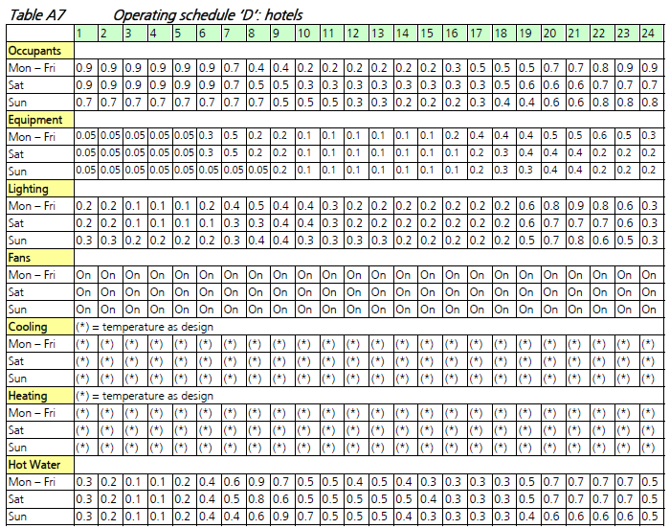

**Equivalent Carbon Dioxide CO2 Emissions Factor**

|  |  |
| --- | --- |
| Since there is a mix of fuel used in this building, the energy performance assessment will be based on the incurred carbon dioxide emission rather than the amount of energy used. The followings show the conversion factors to be used for this purpose: | |
| Electricity | 0.7kg CO2 per kWh electricity consumed  (From BEAM Plus NB v1.2 Appendix 8.3) |
| Town Gas | 3.141 kg CO2 per unit of town gas consumed  (1 unit of town gas = 48MJ)  (From BEAM Circular Letter 2013.115) |

**Compliance of Building Energy Code**

The Code of Practice for Energy Efficiency of Building Services Installation Prescriptive Option, which shall be strictly complied with as a pre-requisite for credits under the building energy performance assessment.

* 1. Exceptional Calculation Method

Exceptional Calculation approaches are adopted for the energy estimation of all kitchen appliances such as electric cooking, washing machine and refrigeration, Car Park, Plumbing & Drainage. The above mentioned items are independent of cooling load, heating load and the weather. The energy consumption of these items is non-dynamic and independent of other factors. In addition, they will become part of the total energy consumption and no savings are claimed of these items.

* + 1. Kitchen Appliances

It is assumed all flat types would have same provision of kitchen appliances including electric cooking, washing machine and refrigerator. The equipment power for each equipment are listed in Table 5.

Table Total kitchen equipment power for different flat types

|  |  |
| --- | --- |
|  | All Flat Types |
| Electric Cooking (kW) | 3.1 |
| Washing Machine (kW) | 2.2 |
| Refrigeration (kWh/yr) | 281 |

Based on the information above, the total equipment power of each tower is calculated and summarized below:

Table Total kitchen equipment power in each tower

|  |  |
| --- | --- |
|  | Power (kW) |
| Electric Cooking | 957.8 |
| Washing Machine | 688.6 |
| Refrigeration | 31.3 |

For refrigeration use, it is assumed the appliance will operate all the time throughout the entire year. For electric cooking and washing machine, many times they will not operate at full capacity because its diversity of use. In order to model them in the energy simulation, it is assumed that the equivalent operational hours is 0.5 hour of full capacity throughout the day for electric cooking and washing machine.

* + 1. Lift System

The lift system in the energy model calculation should include the residential lifts. The building services design would provide the total number of lifts in each tower, rated capacity and rated speed. Based on these information, the baseline motor power consumption can be reference to the BEC 2015 code of practice for lift and escalator installation Section 8.4.1.2.

The proposed lift system will contribute to energy saving by using a motor with less rated power. By calculating the total power consumption from each tower for baseline and proposed case, energy saving can be achieved.

|  |  |  | **BASELINE** | |  | **PROPOSED** | | |
| --- | --- | --- | --- | --- | --- | --- | --- | --- |
| **Rated Capacity (kg)** | **Rated Speed (m/s)** | **Power (kW)** | **Total (kW)** |  | **Power (kW)** | **Total (kW)** | |
| L1 | 900 | 2 | 19.4 | 77.6 |  | 16.5 | 66.0 |
| L2 | 900 | 2 | 19.4 |  | 16.5 |
| L3 | 900 | 2 | 19.4 |  | 16.5 |
| L4 | 900 | 2 | 19.4 |  | 16.5 |

* + 1. Car Park (Lighting & Fan)

Energy consumption for car park related to lighting and fan is calculated as exceptional calculation. energy consumption is calculated and added to energy consumption and peak demand calculation. Please refer to supporting document “20-ExceptionalCalc/ 01 CarPark\_ExcepCalc.pdf” for calculation detail.

* + 1. Plumbing & Drainage Pump

Energy consumption for all the pump related to P&D is calculated as exceptional calculation. According to the water usage estimation submitted in “WU1/Supporting Document/Water Use Estimation\_v2.pdf”,” WU6/Supporting Document/05-WU6-Flush Water Use Estimation\_v2.pdf”, energy consumption is calculated and added to energy consumption and peak demand calculation. Please refer to supporting document “10-Plumbing&Drainage/ EU1\_Energy\_Saving\_ Calculation\_Plumbing.pdf” for substantiation.

1. Results and discussion

The energy simulation results of Proposed Case and Baseline Case in terms of CO2 emission reduction & peak electricity demand reduction will be summarized in this section.

* 1. EU 1 Reduction of CO2 Emissions

Whole Building Energy Performance Assessment is performed to estimate the percentage of energy saving of a whole building load. The objective of EU 1 is to reduce the consumption of non-renewable energy resources and the consequent harmful emissions of Carbon Dioxide (CO2) to the atmosphere.

Since the project building belongs to residential building, the category for Residential Building Types (c) under EU 1 can be chosen as the credit assessment.

From the energy simulation and calculation result, 13.9%, 31.4% of the CO2 emissions reduction can be achieved for residential tower and car park respectively which contributes to 12 points and 15 points respectively out of 15 points in EU 1.

* 1. Simulation Results

The result of the whole building energy simulation showed that the Baseline Case had a total CO2 emission of 1,275.7 Tonnes of CO2, while the Design case building had 1,098.0 Tonnes of CO2 emission for residential tower. For car park, Baseline Case had a total CO2 emission of 51.5 Tonnes of CO2, while the Design case building had 35.3 Tonnes of CO2 emission for residential tower. This is an overall reduction of 13.9%, 31.4% in CO2 emissions for residential tower and car park respectively.

All the results below are already accounted for the exceptional calculation for electric cooking, refrigeration, plumbing & Drainage and car park.

Table Total CO2 emission breakdown of Baseline and Proposed Case for residential tower

|  |  |  |  |
| --- | --- | --- | --- |
| **Residential Tower** | | | |
| **Categories** | **Baseline Case** | **Proposed Case** | **% Saving** |
|  | **(kgCO2)/year** | **(kgCO2)/year** |  |
| Cooling | 377,905 | 240,502 | 36% |
| Lighting | 229,368 | 217,859 | 5% |
| Equipment | 103,152 | 103,152 | 0% |
| Lift | 193,034 | 164,079 | 15% |
| Electric Cooking | 73,414 | 73,414 | 0% |
| Washing Machine | 52,781 | 52,781 | 0% |
| Refrigeration | 191,932 | 191,932 | 0% |
| Mechanical Ventilation | 1,447 | 1,447 | 0% |
| Hot water | 34,285 | 34,285 | 0% |
| Plumbing & Drainage | 18,425 | 18,425 | 0% |
| **Total CO2 Emission (kgCO2)** | **1,275,741** | **1,097,950** | **13.9%** |
| **No. of credit attained** | **12** | | |

Table Average CO2 emission breakdown of Baseline Case for residential tower with rotation



Table Total CO2 emission breakdown of Baseline and Proposed Case for car park

|  |  |  |  |
| --- | --- | --- | --- |
| **Car Park** | | | |
| **Categories** | **Baseline Case** | **Proposed Case** | **% Saving** |
|  | **(kgCO2)/year** | **(kgCO2)/year** |  |
| Lighting | 26,538 | 10,297 | 61.2% |
| Mechanical Ventilation | 24,957 | 25,019 | -0.2% |
| **Total CO2 Emission (kgCO2)** | **51,496** | **35,316** | **31.4%** |
| **No. of credit attained** | **15** | | |

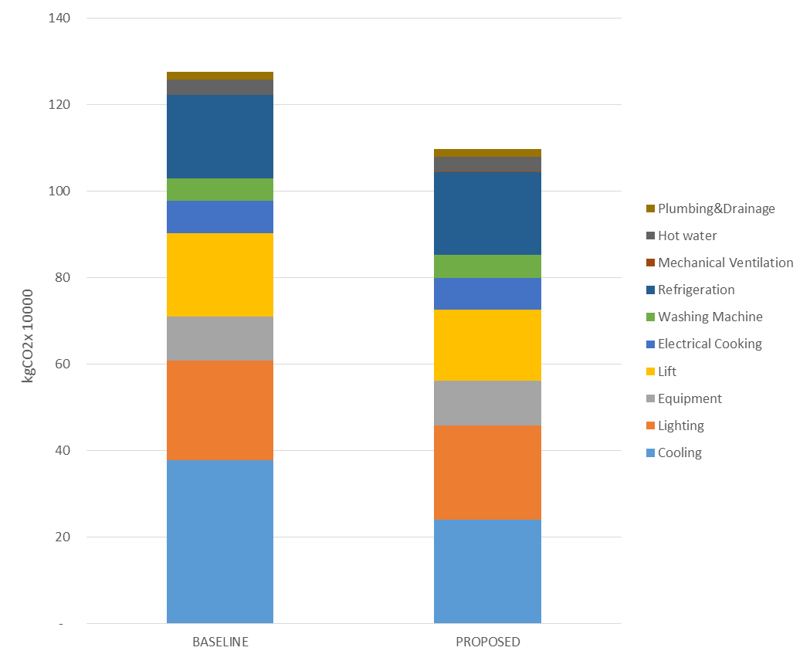

**13.9% Reduction**

Figure CO2 emission for Baseline and Proposed Case for residential tower

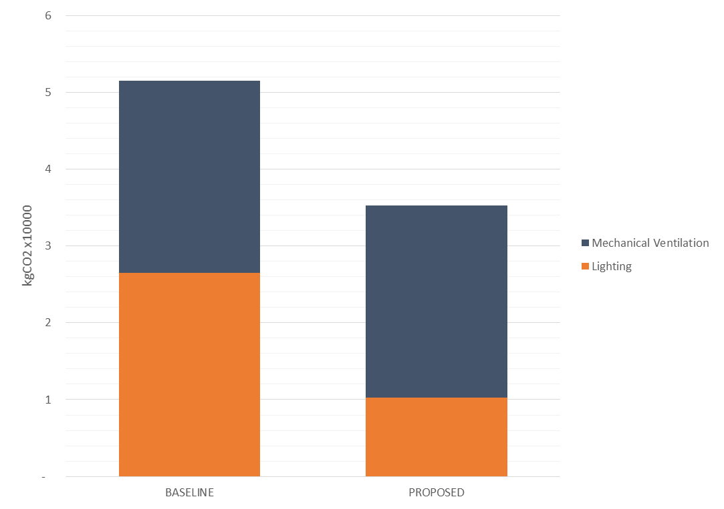

**31.4% Reduction**

Figure CO2 emission for Baseline and Proposed Case for car park

* + 1. Baseline Case and Proposed Design CO2 Breakdown

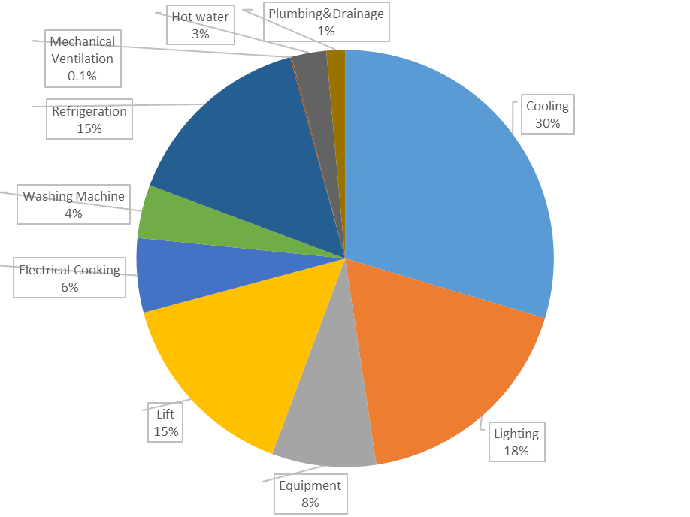

Figure Building CO2 breakdown under Baseline Case

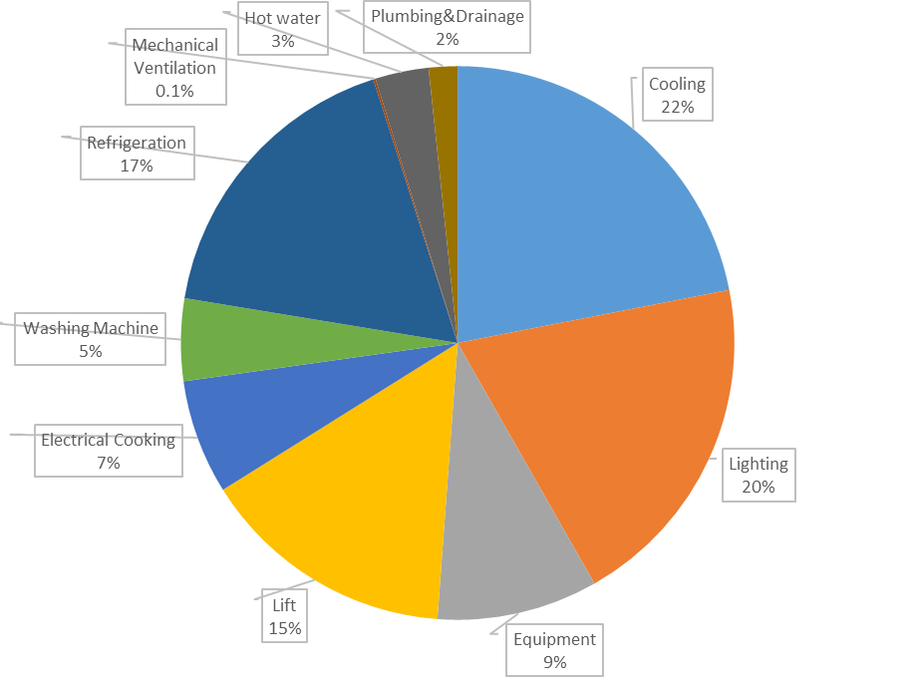

Figure Building CO2 breakdown under Proposed Case

Figure Categorized CO2 saving between Baseline and Proposed Case for residential tower

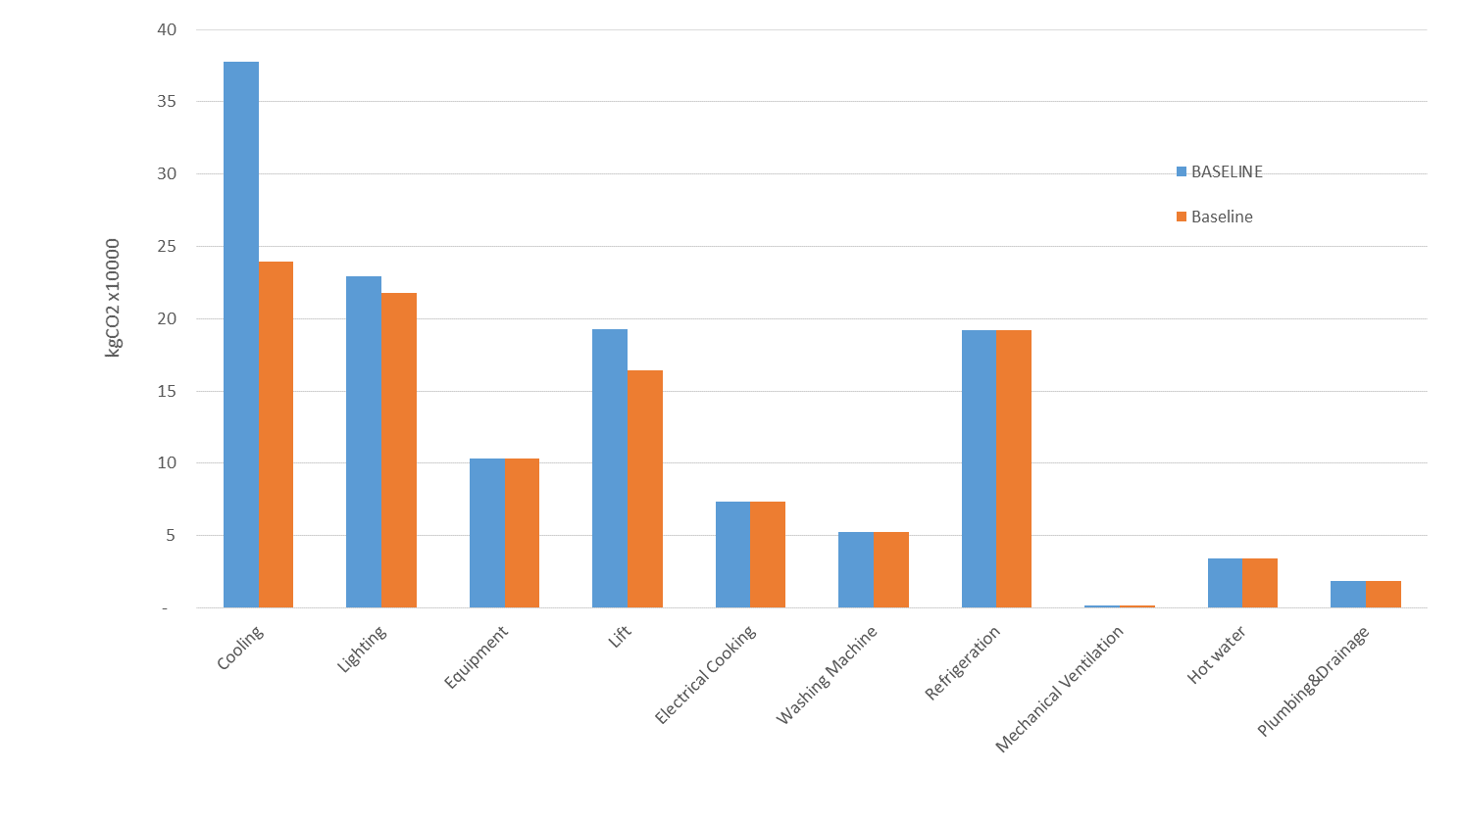

**36% Reduction**

**5% Reduction**

**15% Reduction**

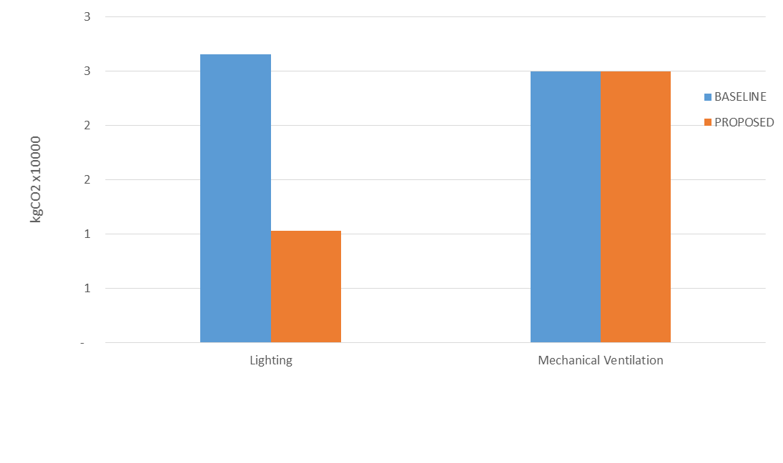

**61% Reduction**

Figure Categorized CO2 saving between Baseline and Proposed Case for car park

* 1. EU 2 Peak Electricity Demand Reduction

The objective of this credit is to encourage energy conservation and methods to reduce peak electricity demand.

According to the Credit Requirement, (c) “Residential Buildings” credit scale should be used for residential tower part, i.e., 1 to 3 credits for a reduction in the maximum electricity demand by 2%, 6% and 9% respectively. Also, (d) “Other Building Type” credit scale should be used for car park part, i.e., 1 to 3 credits for a reduction in the maximum electricity demand by 7%, 11% and 14% respectively.

The Peak Electricity Demand Reduction is summarized in the table as below.

Similar to section 6.2, the peak electricity demand reduction is mainly contributed by the high efficient cooling system. The AC system will operate only from Apr to Oct. A high COP AC unit can reduce the overall electricity usage, as well as peak electricity consumption.

Owing to the energy saving strategies, adopted in the Proposed Case, the peak electricity demand is reduced by 12.2% for residential tower, 31.4% for car park respectively. Therefore, 3 credits should be achieved for residential tower and car park according to BEAM Plus New Buildings v1.2.

Table Monthly Peak Electricity Demand of Baseline and Proposed Case for residential tower

|  |  |  |  |
| --- | --- | --- | --- |
| **Residential Tower** | | | |
| **Month** | **Baseline Case** | **Proposed Case** | **% Reduction** |
|  | **kW** | **kW** |  |
| January | 542.6 | 531.5 | 2.0% |
| February | 542.6 | 531.5 | 2.0% |
| March | 542.6 | 531.5 | 2.0% |
| April | 682.1 | 617.4 | 9.5% |
| May | 707.9 | 635.7 | 10.2% |
| June | 741.3 | 650.6 | 12.2% |
| July | 740.4 | 649.8 | 12.2% |
| August | 729.1 | 645.0 | 11.5% |
| September | 730.2 | 645.6 | 11.6% |
| October | 702.6 | 628.4 | 10.5% |
| November | 542.6 | 531.5 | 2.0% |
| December | 542.6 | 531.5 | 2.0% |
| **Peak Demand Reduction** | | | **12.2%** |
| **No. of credit attained** | **3** | | |

Table Monthly Peak Electricity Demand of Baseline and Proposed Case for car park

|  |  |  |  |
| --- | --- | --- | --- |
| **Residential Tower** | | | |
| **Month** | **Baseline Case** | **Proposed Case** | **% Reduction** |
|  | **kW** | **kW** |  |
| January | 8.4 | 5.8 | 31.4% |
| February | 8.4 | 5.8 | 31.4% |
| March | 8.4 | 5.8 | 31.4% |
| April | 8.4 | 5.8 | 31.4% |
| May | 8.4 | 5.8 | 31.4% |
| June | 8.4 | 5.8 | 31.4% |
| July | 8.4 | 5.8 | 31.4% |
| August | 8.4 | 5.8 | 31.4% |
| September | 8.4 | 5.8 | 31.4% |
| October | 8.4 | 5.8 | 31.4% |
| November | 8.4 | 5.8 | 31.4% |
| December | 8.4 | 5.8 | 31.4% |
| **Peak Demand Reduction** | | | **31.4%** |
| **No. of credit attained** | **3** | | |

Figure Categorized energy saving between Baseline and Proposed Case for residential tower

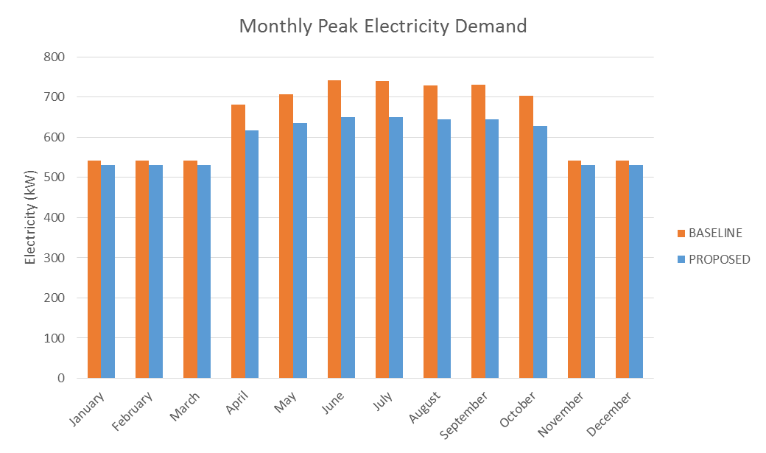

Peak month

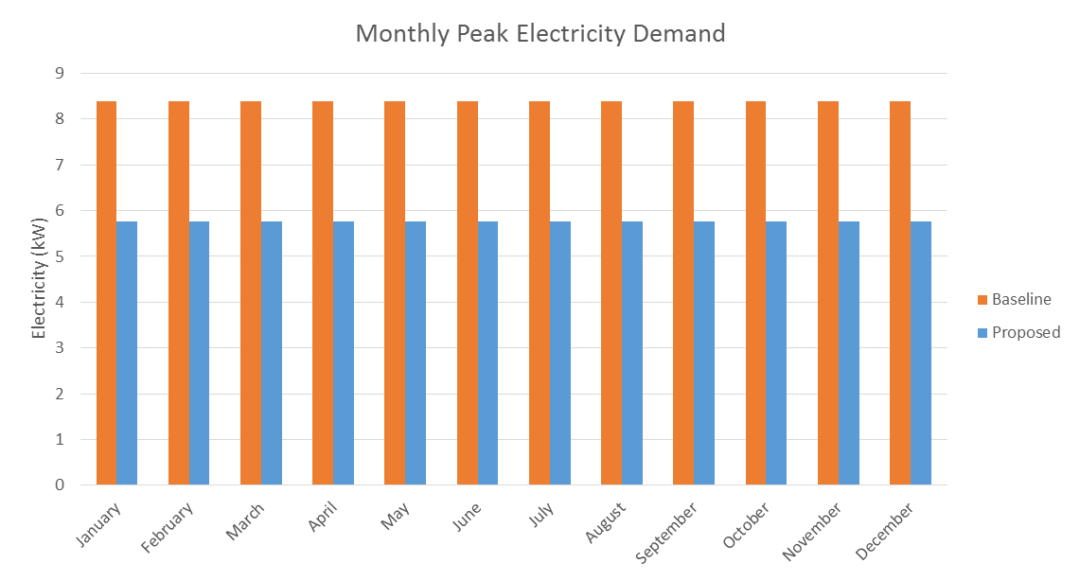

Peak month

Figure Categorized energy saving between Baseline and Proposed Case for car park

1. Conclusion

This energy analysis aims to compare the energy consumption and so the CO2 emission between the Baseline Case (mainly based on BEC2015) and the Proposed Design Case. The analysis result may not reflect the actual energy consumption during the building operation stage, because the energy consumption does depend on couples of assumptions, such as operating schedule, equipment power and the lighting and equipment decided by the users. The assumptions of this analysis comply with the requirements of Building Energy Codes 2015 as well as BEAM Plus Standard v1.2, which are believed that the analysis result is able to identify the Annual Energy Use and CO2 Emission Reduction between the cases based on accredited assumptions.

The Annual CO2 Emission Reduction of the proposed case are around 13.9% for the residential portion, 31.4% for the car park portion which are able to earn 12 points and 15 points from BEAM Plus v1.2 EU 1 respectively.

The peak electricity demand of the proposed case are reduced 12.2% for the residential tower , 31.4% for the car park portion, which are able to earn 3 points from BEAM Plus v1.2 EU2 for residential tower and car park respectively.

Table Point summary for residential tower

|  |  |  |
| --- | --- | --- |
| **BEAM Plus v1.2 Energy Use Credit** | **Maximum Points** | **Project Status** |
| EU Pre-requisite 1  Minimum Energy Performance | Pre-requisite | Compliance |
| EU 1  Reduction of CO2 Emissions | 15 | 12 |
| EU 2  Peak Electricity Demand Reduction | 3 | 3 |

Table Point summary for car park

|  |  |  |
| --- | --- | --- |
| **BEAM Plus v1.2 Energy Use Credit** | **Maximum Points** | **Project Status** |
| EU Pre-requisite 1  Minimum Energy Performance | Pre-requisite | Compliance |
| EU 1  Reduction of CO2 Emissions | 15 | 15 |
| EU 2  Peak Electricity Demand Reduction | 3 | 3 |